In servlet API , we have 2 service(-,-) methods and 7 doXXX(-,-) methods to place request processing logics.

1



* It is servlet Life cycle() method for processing the request.
* In this method, we write the request processing logic.
* This method is originally declared in Servlet(I) and It is implemented as concrete method in GenericServlet Abstract class.
* Drawback:- This method does not allow to work with “Http protocol features”.

2.



* It is not servlet life cycle method.
* In this method also, we place the request processing logic.
* This method is direct overloaded concrete method of HttpServlet Abstract class.
* This method allows us to work with “**http protocol features**”.

3.

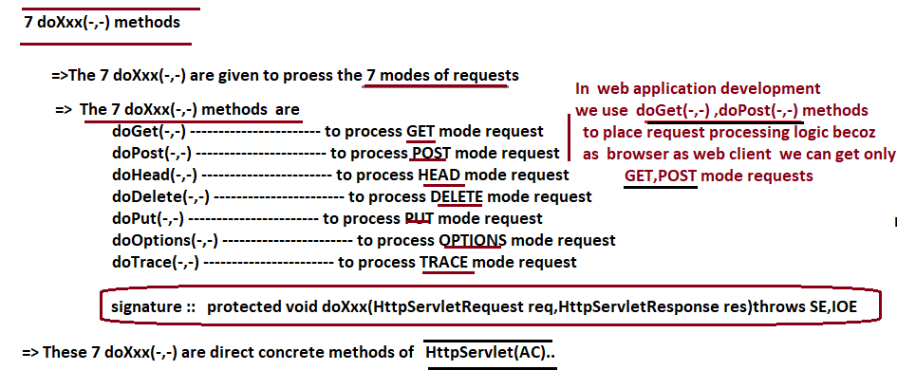

**Note:- 1.**jakarata.servlet.HttpServlet(AC) have only concrete methods though it is given as **Abstract class.**

Therefore, we can’t get logic of HttpServlet Abstract class directly. We get its logic by object of subclass of HttpServlet Abstract class.

2. The best method is to place request processing logic is one of doXXX(-,-) method. Especially doget(-,-) and dopost(-,-) because browser generate request in these 2 modes.

**Public Service(-,-) and protected Service(-,-) pre-defined class Definitions:**

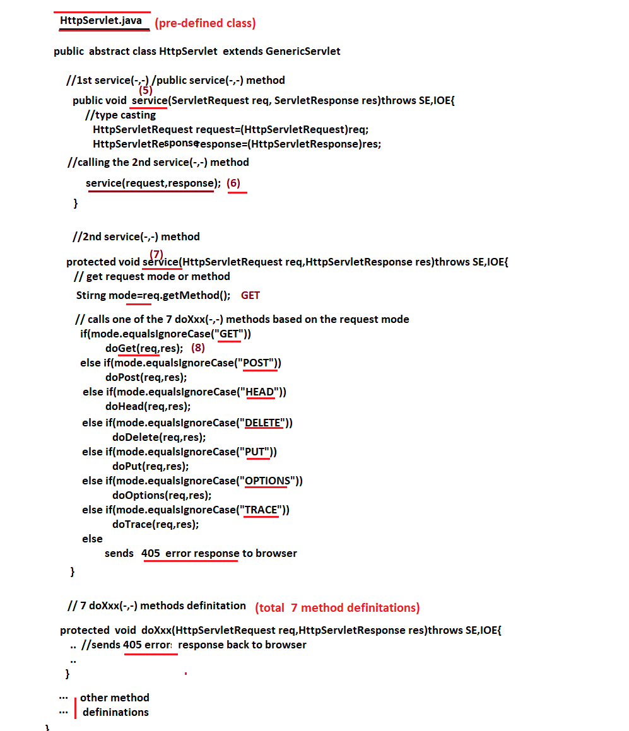

Note:- **The servlet container invokes the public service(-,-) method . The public service(-,-) method internally calling protected service(-,-) method and that invokes one of 7 doxxx(-,-) method based on given request mode.**

**Important points**

**------------------------**

If I place all 3 thods like 1st service(-,-) and 2nd service(-,-) methods our in servlet comp by giving GET mode request then what happens?

Ans) only 1st service(-,-) method of our ser comp executes. Rest of 2nd service(-,-) and doGet(-,-) execution will not happens.

Because Servlet container invokes the public service(-,-)(life cycle method) on object of servlet comp. It is overridden in servlet comp . Therefore its execution will happens and servlet container will not go to GenericServlet(AC) for public service(-,-).

